***Directions:* *Complete the Chapter 10 Programming Challenge on the Kayak Browser and the Kayak Rental Prices. Provide a snippet of the output and of the code for both challenges.***

**1.**

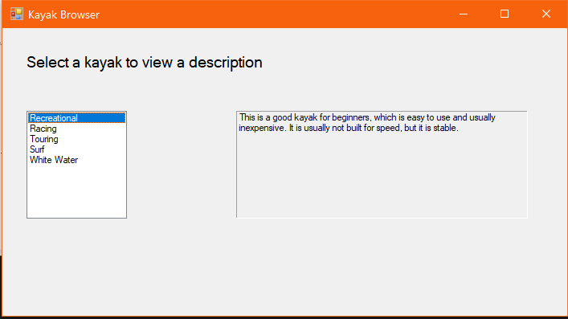

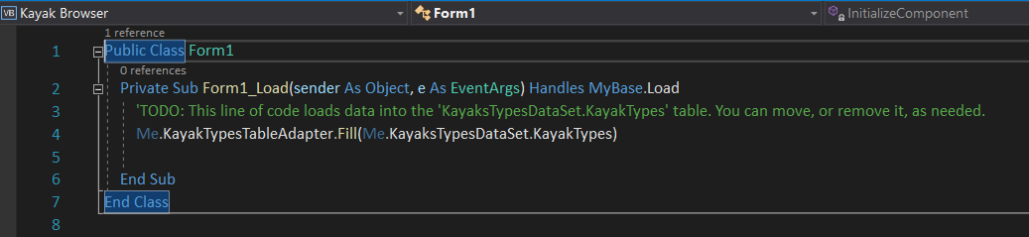

**2.**

